**ONLINE RESTAURANT MANAGEMENT SYSTEM**

PROJECT BY: VISHAKA PAHUJA & MUSKAN NARANG //VISHAN

## RESTAURANT MANAGEMENT SYSTEM

**INTRODUCTION**

"Our Restaurant Management System" is basically a web application. This system is developed to automate day to day activity of a restaurant. Restaurant is a kind of business that serves people all over world with ready-made food. This system is developed to provide service facility to restaurant and also to the customer. This restaurant management system can be used by owner in a restaurant to handle the customers, their orders and can help them easily find free tables or place orders. The services that are provided is food ordering by the customer through the system online, menu information management and report. The restaurant menu is organized by categories (Starters, Soups & Salads, Family Platters, Deserts and Drinks) of menu items. Main objective to build the system is to provide ordering and reservation service by online to the customer. Each menu item has a name and price. With this system online, ordering and reservation management will become easier and systematic to replace traditional system where are still using paper. This project is to facilitate customer for make online ordering.

After successful login the customer can access the menu page with the items listed. The main point of developing this system is to help restaurant administrator manage the restaurant business and help customer for online ordering and reserve table.

At Management side, initially the staff member has to login, for login:

THE USERNAME IS:

VISHAN //you can use capital or small letters

THE PASSWORD IS:

1000

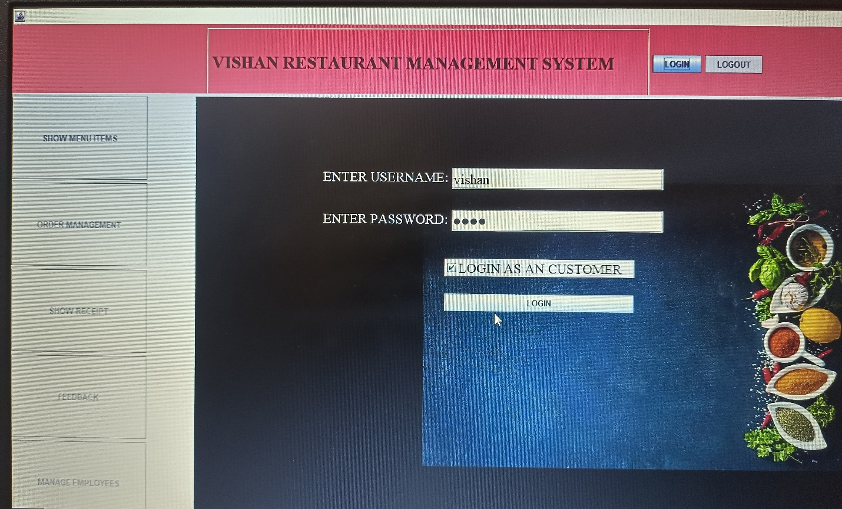

**PROJECT LIBRARIES**

1. **import javax.swing.*;**
2. **import java.awt.*;**
3. **import java.awt.event.ActionEvent;**
4. **import java.awt.event.ActionListener;**
5. **import java.io.File;**
6. **import java.io.FileWriter;**
7. **import java.util.*;**

**Module of the restaurant management system**

**Customer Online Ordering & Reservation Module**

Customer online ordering and reservation module provides a form that needs to be fulfilling in term of ordering food and reservation table via online.

**Feedback Module**

Based on food or everything about the restaurant, customer can send any suggestion or comment to the restaurant with feedback card. From this card, side of restaurant will know their weaknesses and strengths.

**Menu &order Module**

Menu module is food that restaurant prepared for customer. This module, customer can view the menu and make decision for order.

**MANAGE EMPLOYEES MODULE**

This can only be used by manager not by customers.

When you will login not as customer ,all the options will be enabled to you namely :

1. SHOW MENU ITEMS
2. ORDER MANAGEMENT
3. SHOW RECEIPT
4. FEEDBACK
5. MANAGE EMPLOYEES

As a customer, 1st 4 options will be enabled to you..!